
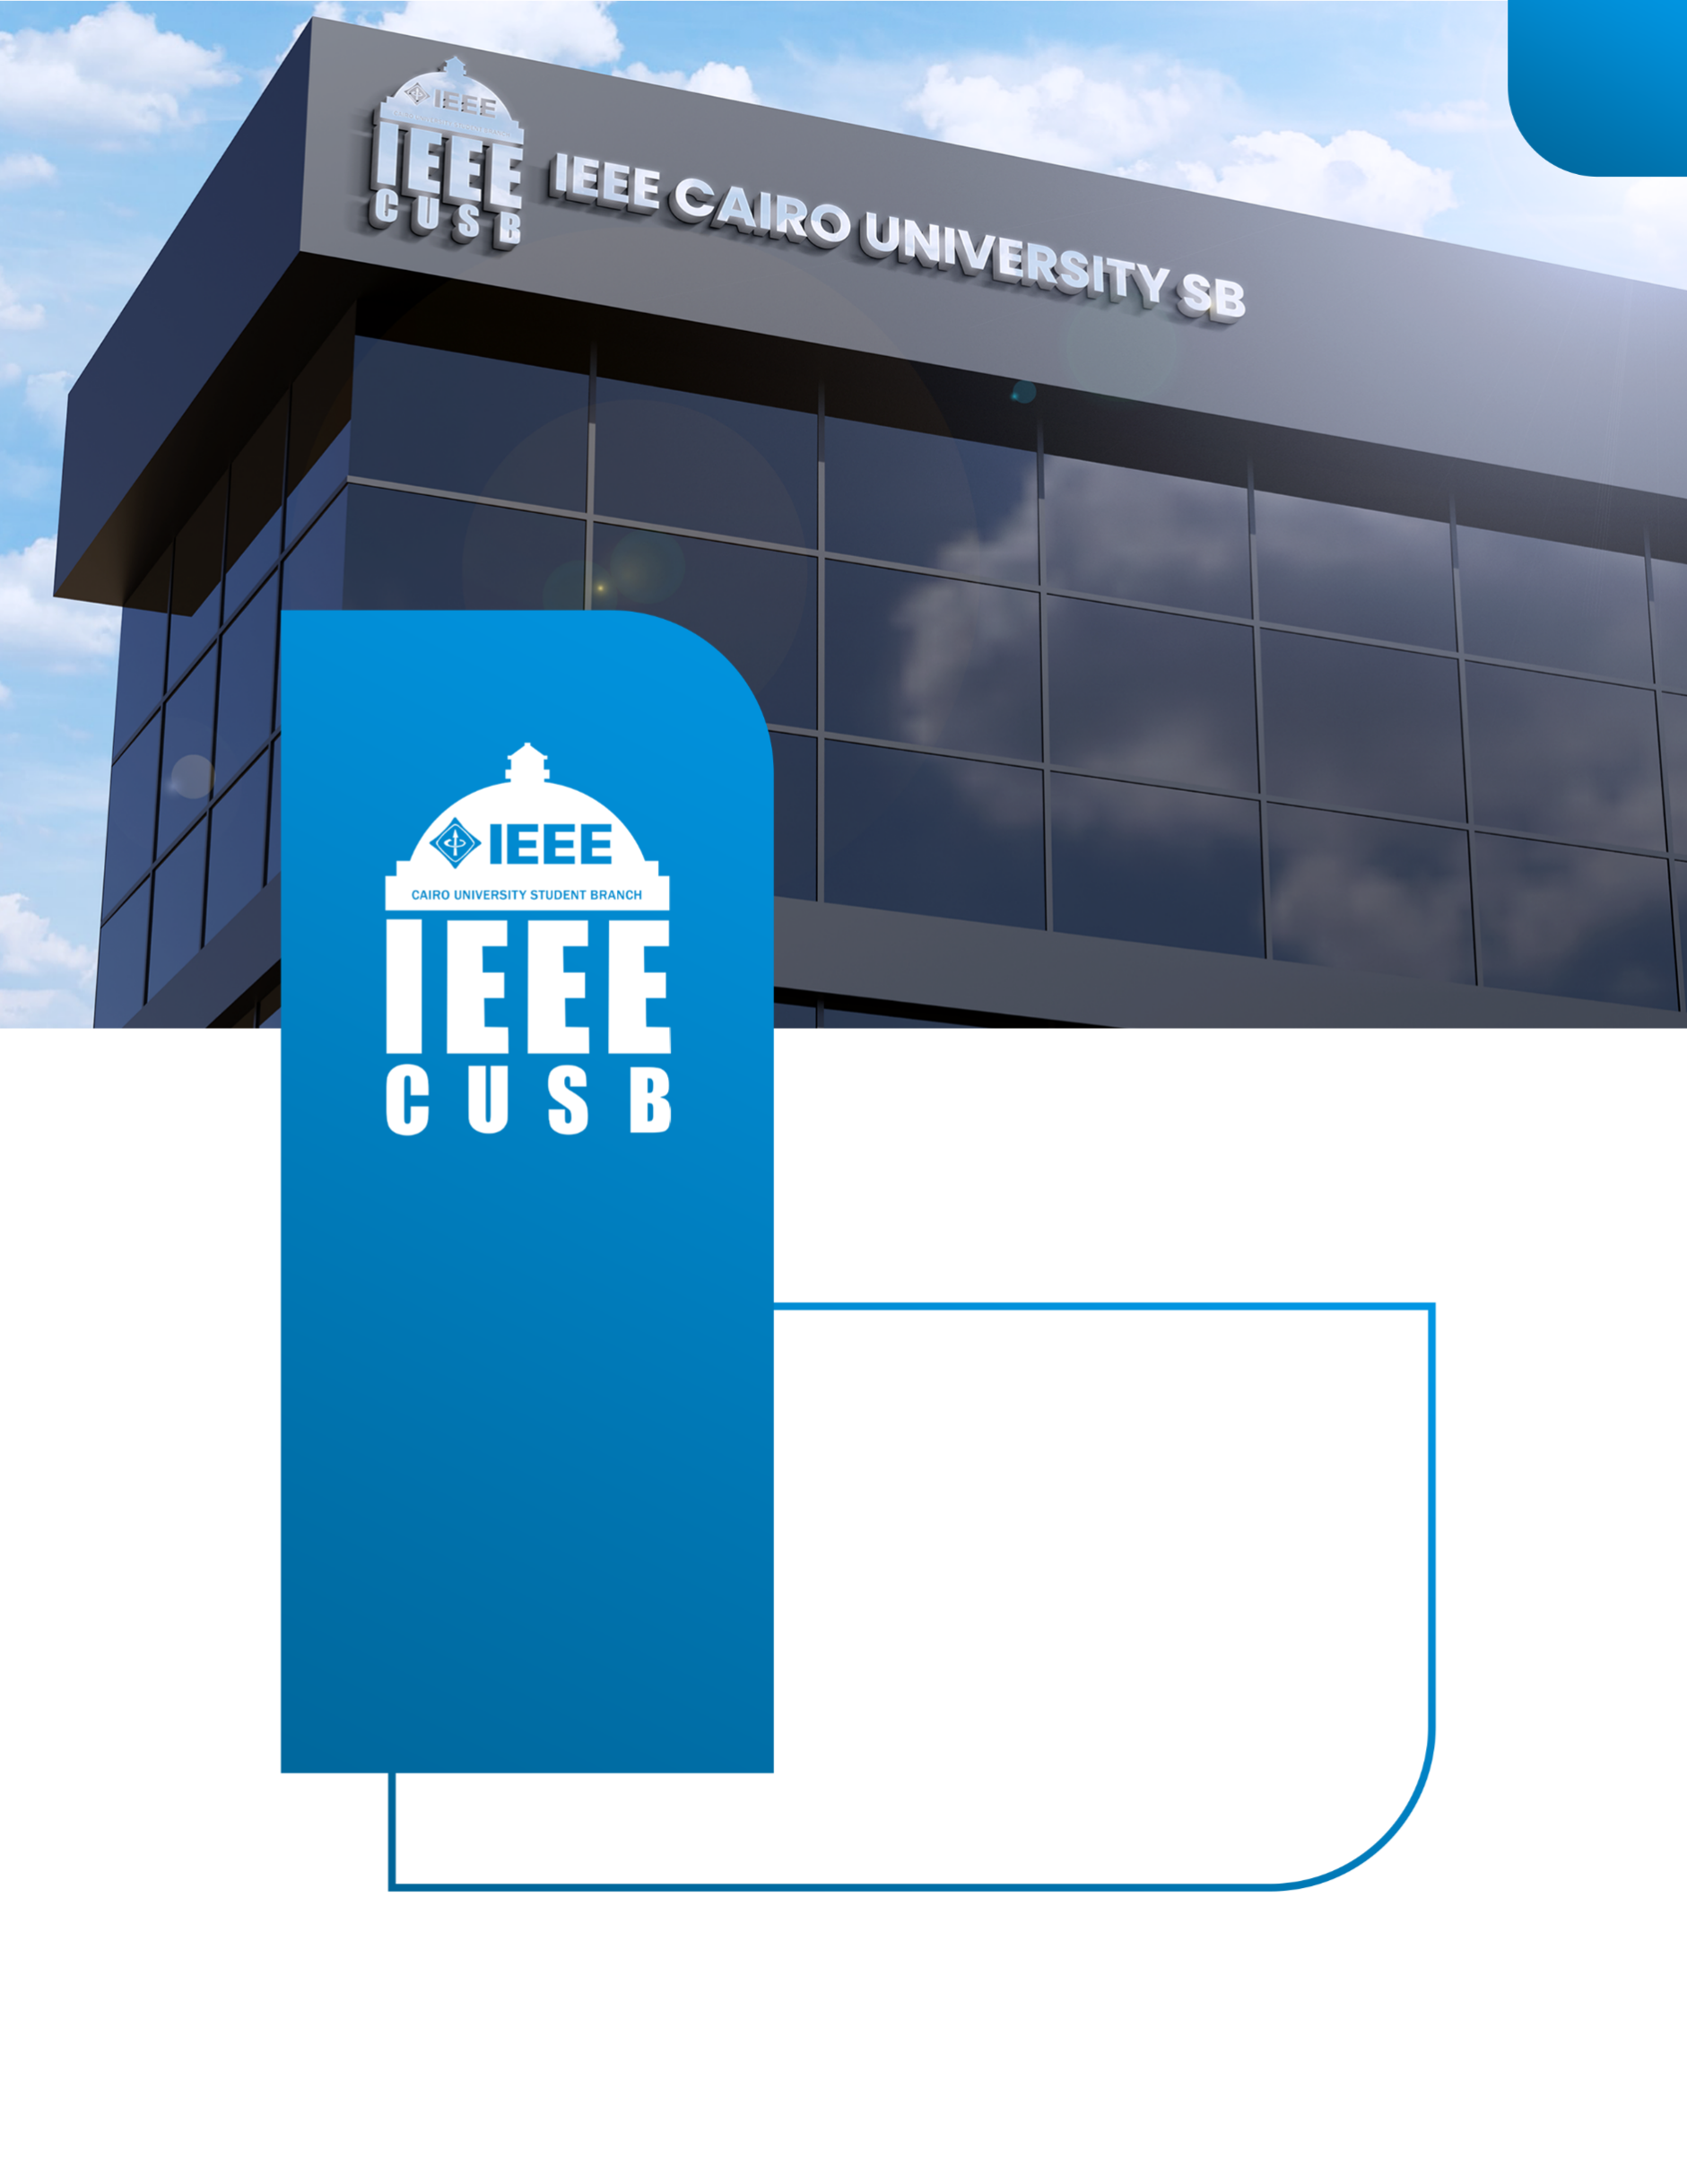
Receipt
Embedded AVR Work
2025-2026
ieeecusb
IEEE CAIRO UNIVERSITY
STUDENT BRANCH


IEEE CUSB – AVR for Beginners Workshop
Session 1

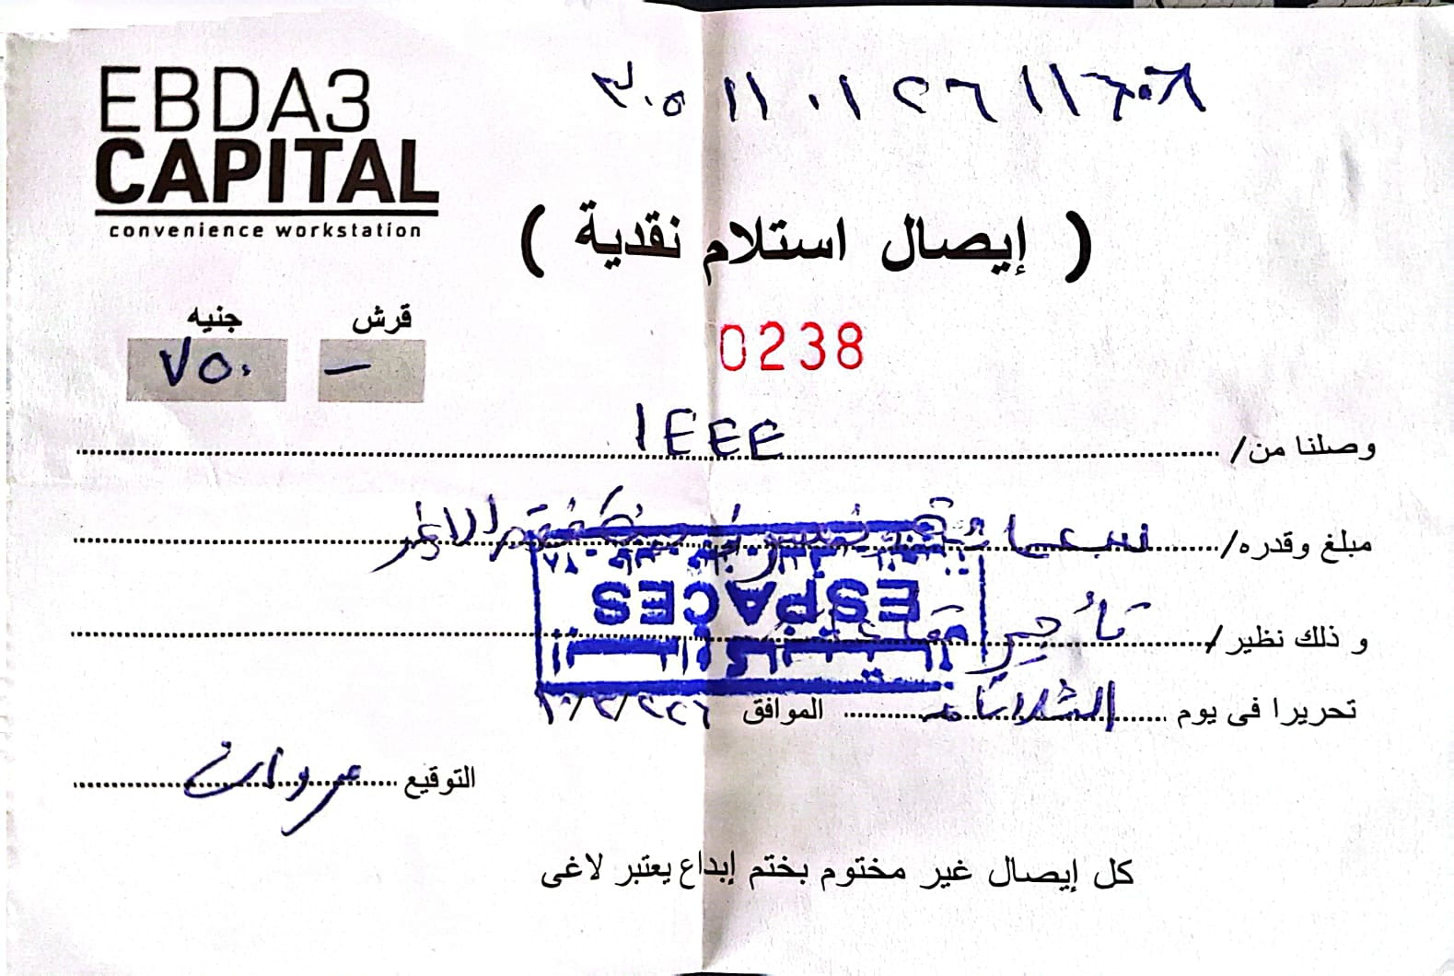

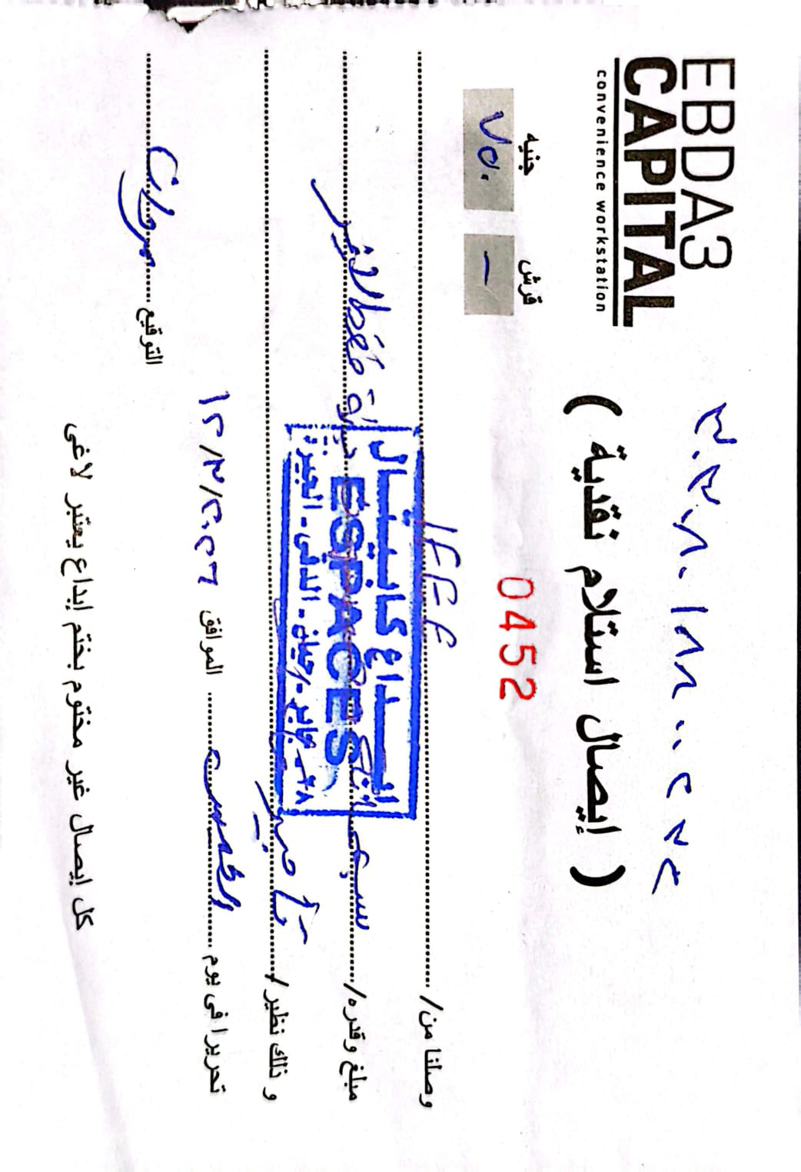


Session 2
IEEE CUSB – AVR for Beginners Workshop



Session 3
IEEE CUSB – AVR for Beginners Workshop

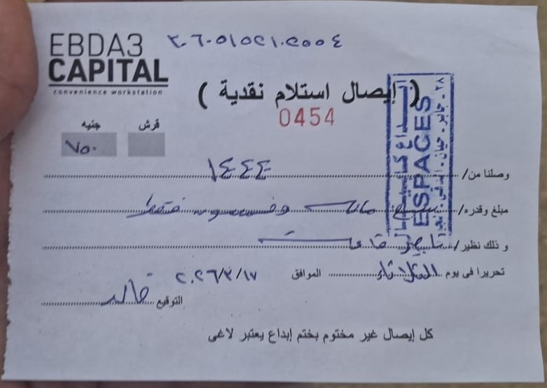



Session 4
IEEE CUSB – AVR for Beginners Workshop
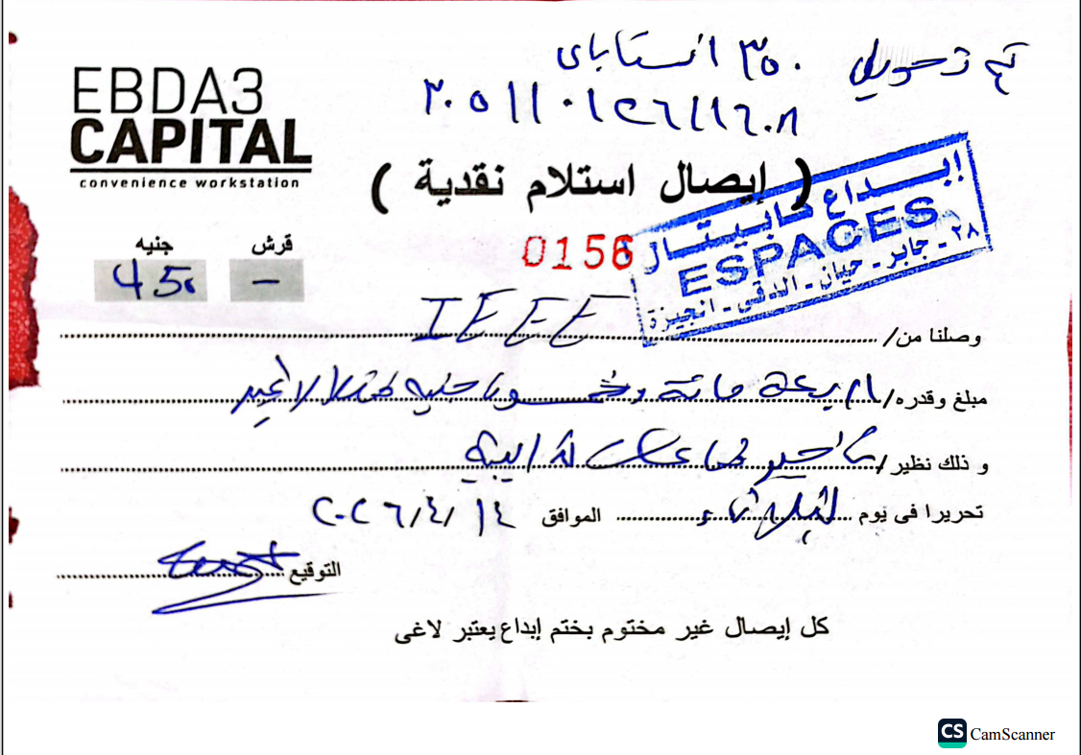



Session 5
IEEE CUSB – AVR for Beginners Workshop
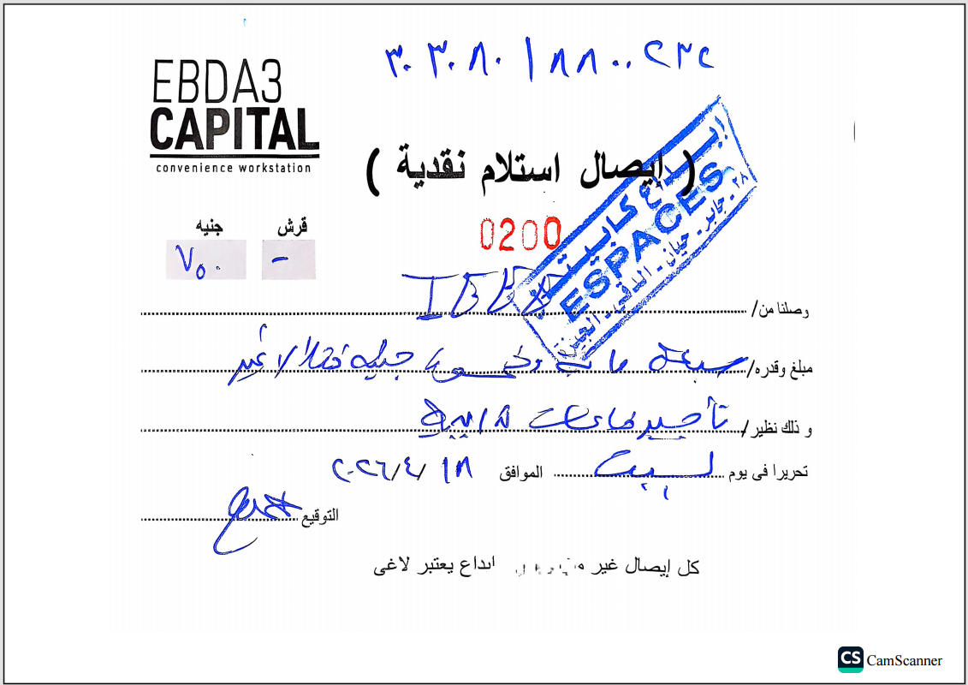



Session 6
IEEE CUSB – AVR for Beginners Workshop

